SHIRECON 2024

KINGS OF WAR
PLAYERS PACK

Saturday 20th April

Sylvania Heights Community & Youth Club, Box Road, Sylvania Heights, NSW

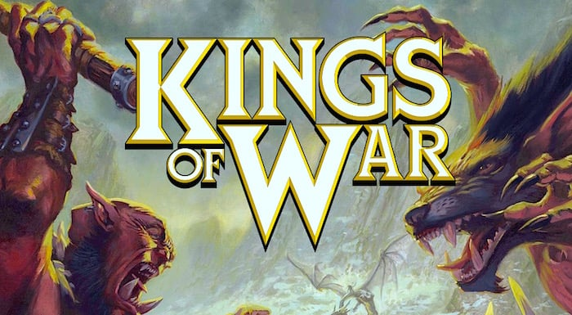
WELCOME NOTE

Welcome to Shirecon 2024, a Kings of War event held as part of the Shirecon gaming convention in Sylvania Heights Sydney. This will be an event incorporating both gaming and hobby for the ultimate Kings of War experience for all levels of gamers. There is nothing better than seeing beautifully painted armies matched on tables with great terrain. Please have a read and certainly sign up!

Tournament Organiser for Kings of War SHIRECON 2024:
Paul Collins: paul.k.collins@gmail.com

WHAT
3 Games of Kings of War 3rd edition – 2000 points

WHERE
Shirecon Convention
Sylvania Heights Community & Youth Club, Box Road, Sylvania Heights, NSW

WHEN
20th April 2024
Saturday: 8:30am to 4:50pm

TICKETS
Tickets are $TBA (plus booking fee).
Tickets purchased after TBA may incur a late fee.
Tickets are available following this link: TBA
This event will be run using the Mantic Companion App. Please sign up for the event using the code below. Players will be added to the event once payment is confirmed.
Mantic Companion App Code: TBA

RULES
Kings of War 3rd Edition rules will be used as well as the most recent rules updates on the Mantic Companion app including:
- Allies are not allowed.
- The withdraw rule will be in effect with -1 to hit penalty for charging afterwards
- Should FAQ, Errata or faction updates be made before the event, the TO will determine if the changes will be allowed in the event.
- The TO will play if there is an odd number of players in a round. The TOs list will be published ahead of the list submission deadline.

ARMY LISTS
Players are to bring 2 printed copies of their army list to share with their opponents during the games. Lists should be submitted to the Mantic Companion App by midnight on Wednesday 13th April using the code below.
Mantic Companion App Code: TBA
Players will earn 5 additional tournament points for submitting their list on time.
HOBBY
Armies must be representative and not heavily proxied. It should be clear to any player what the unit is intended to be within the list and clearly look like it belongs.
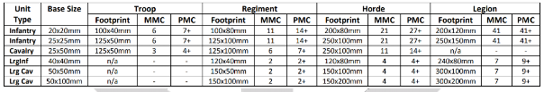
Additionally, all units must meet minimum model count requirements.
If you have any queries or uncertainty about your army or particular units meeting the above criteria, please contact the TO in advance.
There is up to 20 tournament points available for hobby. Scoring will be determined by the TO & the points will be added at the end of the tournament. Refer to table below.

HOBBY SCORING TABLE
TYPE | DESCRIPTION | POINTS AVAILABLE
MODELLING | Model selection, Models representative of their units, Mantic army, MMC, Conversions, Cohesiveness, etc | 5
PAINTING | 3 Colour Minimum, Shading, Highlighting, Consistent paint scheme, Freehand, etc | 5
BASING | Consistent basing across army, Range of materials used, Diorama style multi-bases, etc | 5
THEME | Theme portrayed visually, Fluff or backstory, Display board, Wow! factor, etc | 5
TOTAL /20

SPORTS
At the end of the final game, players will be asked to vote for their favourite opponent. Players will earn 1 tournament point for each favourite opponent vote they receive, for a total of up to 4 bonus tournament points.

TERRAIN
Games will be played on 6’ x 4’ tables. There will be 10 pieces of terrain on each table. Each table will have the same set up for each game. The setup time should be used to place terrain per the supplied terrain maps.
Terrain Type | Quantity | Height
Hills | 2 | 3
Blocking | 2 | 8
Forests | 2 | 10
Obstacles | 2 | 2 | Never block line of sight
Flat (fields/ponds) | 2 | See below | Difficult

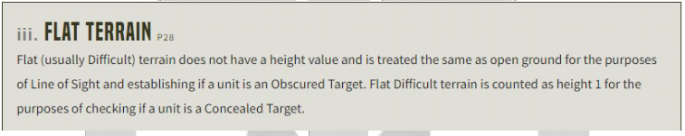

SCENARIOS
Scenarios will be selected by the TO and remain hidden until the start of the event. Players are advised to bring their own objective makers.

SCHEDULE
All rounds must be played using a chess clock. If a player runs out of time on their clock, they must finish their current game action (EG finish the current combat, roll the nerve test and reform). If their opponent still has time (and turns) to play, they may continue to do so. Victory conditions are worked out as normal when both players have concluded their allotted turns.
Round timings in the schedule below will be strictly adhered to so the event ends on time. Once the round timer ends, players will be asked to complete the current phase they are in before dice down. Players may continue playing into the lunch break if they wish to finish their remaining turns.

Saturday 20th April, 2024
Arrive by 8:30am for player registration
Game | Start Time | End Time
Player Meeting | 8:30 AM | 8:55 AM
Game 1 | 9:00 AM | 11:00 AM
Game 2 | 11:20 AM | 13:20 PM
Lunch + Hobby Presentation | 13:20 PM | 14:20 PM
Game 3 | 14:20 PM | 16:20 PM
Packup & Award Presentation | 16:20 PM | 16:50 PM

SCORING
Blackjack scoring will be used. This can be found here:
https://kingsofwaraustralia.com/blackjack/?season=&state=
Scoring will be done using the Mantic Companion App. Please sign up for the event using the code below. Players will be added to the event once payment is confirmed.
Mantic Companion App Code: TBA
There are a total of 92 points on offer across the weekend, the winner will be the player with the highest total. These points are distributed as follows:
CATEGORY | DETAILS | POINTS
List submission | Submitting your army list before midnight 13th April 2024 | 5
Battle points | Each of the 3 games has a possible 21 points available | 63
Hobby points | As detailed above in the Hobby section | 20
Sports Points | As detailed above in the Sports section | 4
TOTAL |  | 92

