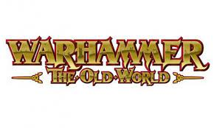
The Shiretown Showdown at Shirecon
This will be the first tournament in NSW for Warhammer The Old World. The aim of this event is to invite everyone to come and play this fresh edition of the game and to bring as many new and returning players back to the scene to create a healthy and lively community which will hopefully continue to thrive long after this event.
Whether you have played previous editions or are brand new to the game, everyone is welcome!

When
Shirecon is a two day event on April 20th & 21st 2024

Where
Sylvania Heights Community & Youth Club at 288 Box Road, Sylvania NSW 2224

Tournament Organiser
Matt Morris – Contactable via email warintheoldworld@gmail.com or mobile 0416168584.

Ticketing
Tickets for this 2 day event will be $50 per person.

Rules and Army Supplements
Rulebooks and Army Books from Warhammer: The Old World

Prizes & Awards: TBD

Saturday Sunday 21st
8:30am | Registration | 9:00am | Game 3
9:00am | Game 1 | 12:30pm | Lunch and Army Voting
12:30pm | Lunch | 1:30pm | Game 4
1:30pm | Game 2 | 4:45pm | Awards

Please try and arrive by 8:30 each day. This provides enough time for each player to be assigned to their tables and get set up in preparation for a 9:00am start. Each game, you will have 3 hours to complete 6 turns(with a bit extra as it’s a new game). Time notifications will be provided at 30 minute intervals and then every 5 minutes once below the 15 minute mark.

All first round opponents will be drawn at random. I’ll post the pairings on Friday 12th April 2024.
All rounds after that will be drawn based on your score relative to other players. Grudge matches can be arranged through the tournament organiser prior to the event as long as both players agree.

Army Composition
All armies are to be no more than 2000 points and must follow the normal restrictions set out in
Warhammer: The Old World Rulebook (Big Blue Book).

Army lists from the Ravening Hordes, Forces of Fantasy and ALL legacy armies will be permitted at this event.

The Forces of Evil: Ravening Hordes:
- Orc & Goblin Tribes
- Warriors of Chaos
- Beastmen Brayherds
- Tomb Kings of Khemri

The Forces of Good: Forces of Fantasy
- Dwarfen Mountain Holds
- The Empire of Man
- Kingdom of Bretonnia
- The Wood Elf Realms
- The High Elf Realms

Legacy Armies
- Skaven
- Dark Elves
- Vampire Counts
- Ogre Kingdoms
- Lizardmen
- Daemons of Chaos
- Chaos Dwarfs

This event aims to be fun and allow players the flexibility and freedom to build their army lists the way they like as long as it’s legal.

A note on composition – While creative list building is encouraged it is also your responsibility as a player to ensure that this is a fun setting so please take this into account when you build your list. There are no restrictions other than those that exist within the game, however please consider the overall experience that this event is about when writing your list and how your opponent might feel when facing it across the table. This doesn’t mean that you have to write a “soft” list that will lose every game but please avoid writing a list that is designed to avoid interacting with your opponent or removes the fun from the contest.

The TO may ask you to re-submit your list if it is deemed to be not in the spirit of the event. The best thing to do is ask yourself “Does my list give my opponent a fair chance of competing in the game?” If your answer to that question is NO then the TO will probably think the same way and it’s likely that you will be asked to resubmit your list. If you are new to the game or are unsure about how powerful your list is then please feel free to get in touch and I am more than happy to give guidance.

Special characters, Mercenaries and Allies will not be permitted at this event. Players must do their best in bringing their armies on the correct base sizes or obtaining movement trays that provide the new base sizes for your army. If you cannot bring your models on the correct base size, please advise your opponent prior to starting the game.

Key Dates
Please submit your army lists to warintheoldworld@gmail.com no later than 11:59PM Friday 5th April, 2024 (2 weekends prior to the event) this gives the TO time to review all the lists and ensure accuracy and enough time for any players to re-submit lists, if necessary. This also helps with running a smooth event and keeping it fair for everyone. You are welcome to email me if you have any questions as well.

Open Lists
This event will run with an open list format which means before you deploy your models on the table you must discuss your list with your opponent and explain any equipment, magic items, powers and abilities that your models or units have. Models that are meant to be hidden such as fanatics/assassins etc need to be mentioned as part of the list but the location of these models remains secret until they are revealed during the game.

Sportsmanship
This is a new game for everyone. There’s going to be times when players get rules wrong, which is ok. Please be patient with each other and try working it out together. If unsure, please call the TO over to discuss.

Let’s make this a fair and honest in-game environment so everyone can have fun. Players must try their best to accurately execute the rules of the game and fully cooperate with opponents to honestly answer any questions that arise before and during the game. Players are also responsible for holding their opponents to the same standards.

The Tournament Organiser (TO) will not be able to observe every game. if a player is made uncomfortable by something his opponent is doing they should tell their opponent about it and explain what the opponent can do to maintain a fair, honest, and fun in-game environment. If the behaviour continues or a dispute arises, the players should call the TO and explain the situation. The TO has the final word on rules questions or debates.

Players must present a mature and polite demeanour to their opponents and the TO. Failure to do so will result in immediate disqualification. A TO can also disqualify a player for any incident that is deemed unsporting. Disqualified players cannot win any awards and will be barred from further events.

Terrain
All woods will be classified as Difficult Terrain and small rivers, swamps and ponds will be classified as Dangerous Terrain. The rest of the terrain rules that start on page 267 of the BBB will be as normal.

Scenarios
Game 1: Open Battle
This scenario represents a classic battle fought between two rival armies meeting at an ideal location for a day of fighting.
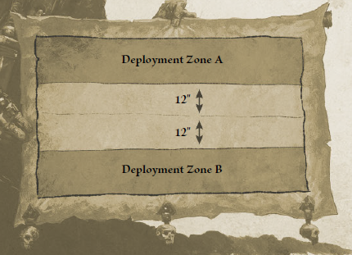

Deployment
Once the battlefield has been set up, the winner of a roll-off chooses which player will deploy the first unit. The winner
of this roll-off must also choose their deployment zone (A or B), as shown on the map opposite. Players deploy their armies
using the alternating units method, as described on page 285 of the BBB.

First Turn
Once deployment is complete, the winner of a roll-off takes the first turn. The player that finished deploying their army first adds +1 to their roll.

Game Length
The battle will last for six rounds, until one side concedes, or until the time limit is reached.

Game 2: Break Point
This scenario represents a battle fought to the grim death – a battle not unlike a pitched battle, but one that will rage until one side is forced to concede.

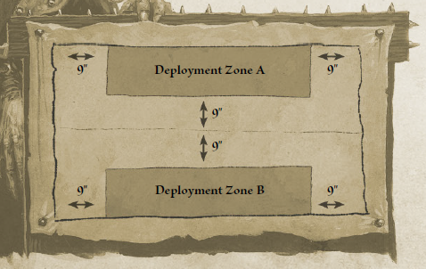

Deployment
Once the battlefield has been set up, the winner of a roll-off chooses which player will deploy the first unit. The winner
of this roll-off must also choose their deployment zone (A or B), as shown on the map opposite. Players deploy their armies
using the alternating units method, as described on page 285 of the BBB.

First Turn
Once deployment is complete, the winner of a roll-off takes the first turn. The player that finished deploying their army
first adds +1 to their roll.

Game Length
The battle will last for six rounds, until one side concedes, or until the time limit is reached.

Scenario Special Rules
Break Point: All armies have a breaking point. This is equal to a quarter (25%) of the total Unit Strength of the army at the
start of the game. To calculate the break point of your army, simply add together the Unit Strength of every unit (including
characters) in your muster list and divide the total by four, rounding fractions down. With each model removed from play as a casualty and with each unit destroyed, an army approaches its break point. If, during any Start of Turn sub-phase, the remaining Unit Strength of either army has fallen below its break point, that army is considered to have ‘broken’. At this point, the game
ends as models begin to flee, crumble into dust, dematerialise, and so forth.

Game 3: Command & Control the Arcane Monolith!
This scenario represents a battle fought for control of a special feature – a significant terrain feature at the centre of the table.

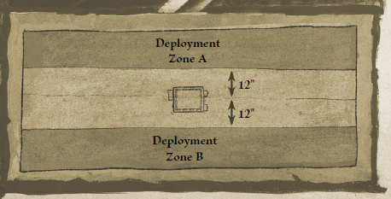

Deployment
Once the battlefield has been set up, the winner of a roll-off chooses which player will deploy the first unit. The winner of this roll-off must also choose their deployment zone (A or B), as shown on the map opposite. Players deploy their armies using the alternating units method, as described on page 285 of the BBB.
First Turn
Once deployment is complete, the winner of a roll-off takes the first turn. The player that finished deploying their army first adds +1 to their roll.

Game Length
The battle will last for six rounds, until one side concedes, or until the time limit is reached.

Scenario Special Rules:
Controlling an Arcane Monolith
An arcane monolith is controlled by proximity. This means that a special feature can be controlled by a unit that is within 6" of it, that has a Unit Strength of five or more and that is not fleeing. If two or more eligible, enemy units are within 6", the unit closest to the special feature controls it. If two enemy units are equally close, the feature is ‘contested’ and neither unit controls it. (as described on page 272 of the BBB).

“A Tingle in the Air”: The air around the arcane monolith tingles strangely, and those that stand too close report of a funny taste in their mouth. The unit that controls an arcane monolith gains Magic Resistance (-1).

Locus of Power: Wizards are able to draw upon the power that seeps from the monolith, channelling it into their spells. If the arcane monolith is controlled by a Wizard, that Wizard may re-roll a single dice that rolls a natural 1 when making any Casting roll.

Victory Points: Controlling an important landmark is a significant achievement. To represent this, if either player controls this special feature at the end of the battle, that player is awarded a bonus of 50 Victory Points.

Game 4: Open Battle (same as Game 1!)

Victory Points:
The following victory points apply to all scenarios, plus any other points you get for scenario objectives as specified with each Game description.
- Each enemy unit that has been destroyed or that has fled off the battlefield is worth a number of Victory Points equal to 100% of its points cost.
- Each enemy unit that is fleeing at the end of the battle is worth a number of Victory Points equal to 50% of its points cost (rounding fractions up). For example, a unit that cost your opponent 351 points to field would be worth 176 Victory Points to you if it is fleeing when the battle ends.
- Each enemy unit that has been reduced to less than 25% of its starting Unit Strength at the end of the battle is worth a number of Victory Points equal to 25% of its points cost (rounding fractions up).

The King is Dead: If the enemy General is slain, has fled off the battlefield or is fleeing when the game ends, you win a bonus of 100 Victory Points.

Trophies of War: You win a bonus of 50 Victory Points for every enemy standard claimed as a trophy, as described on page 200 of the BBB. Additionally, if the enemy Battle Standard Bearer is slain, has fled off the battlefield or is fleeing when the game ends, you win another bonus of 50 Victory Points.

Scoring – Battle Points
Victory Point Margin | Winner Battle Points | Not Winner Battle Points
0-200 | 10 | 10
201-400 | 11 | 9
401-650 | 12 | 8
651-850 | 13 | 7
851-1100 | 14 | 6
1101-1300 | 15 | 5
1301-1550 | 16 | 4
1551-1750 | 17 | 3
1751-1950 | 18 | 2
1951-2200 | 19 | 1
2200+ | 20 | 0

